<Home a Heaven>

**Software Requirements Specification**

Version 1.0



**Group Id: F2002E022B(BC150403336)**

**Supervisor Name:**NeelamAlam

**Revision History**

|  |  |  |  |
| --- | --- | --- | --- |
| **Date (dd/mm/yyyy)** | **Version** | **Description** | **Author** |
| 18-Dec-20 | 1.0 | This project is a web-based application project Name “Home a Heaven”. In this project, I will create an online web store for shopping different types of decorum as like wall hanging, table lamps, flower decoration, wall clocks, and many more decoration items. First of all, it is a new trend to purchase online things as well as In this situation COVID19 this project will help people so much anyone can visit this site easily and order their favorite decorum piece. | **Group ID**  **F2002E022B**  **VU ID**  **(BC150403336)** |
|  |  |  |  |
|  |  |  |  |
|  |  |  |  |

**Table of Contents**

1. Scope (of the project)
2. Functional Requirements Non Functional requirements
3. Use Case Diagram
4. Usage Scenarios
5. Adopted Methodology
6. Work Plan (Use MS Project to create Schedule/Work Plan)

**SRS Document**

Scope of Project:

The internet is one of the best and full of a significant source of information and helping materials. So, with the help of the internet, I created a project and in this online web-based project anyone can visit and order beautiful wall hanging items like wall clocks, lamps, table lamps, Shelves, and many more things that make our walls beautiful and more attractive. Anyone can get his/her ideal decorum piece at home. Customers don’t have to go to a shop or meandering in various shops. This project will help people in this current situation when everyone is fear of COVID-19 and where is prohibited to visit malls and visiting areas. So, with the help of the internet, anyone can visit it for free and can order beautiful decorum pieces according to his/her taste/desire. This online project “Home a Heaven” giving chance its customer to shop 24/7. It will help customers to browse through the shop and purchase them without having to visit the shop physically. This system will help the customer to maintain their cart for addition or removal. One thing is for sure about security, this is the main issue in web-based shopping is the security of customers and their budgetary data. This spot surety of security to its clients of customer’s own and their budgetary data.

**Functional and non Functional Requirements:**

**Functional Requirements:**

1. There is an “Admin” profile that will have all access to the system.
2. Admin can update/delete categories.
3. Admin can update/delete categories orders.
4. Admin can update categories sale price.
5. Admin Can add/Register any member/user with the following fields.

* Username
* Passwords
* Email Id
* Contact No
* Address

1. Users can visit and order any decorum items after registration or without registration.
2. Users can save his/her collection to his/her cart by just clicking the “Add to cart” button.
3. Users have options to add or delete items from his/her cart.
4. Users can view overall selected items, price, and the total amount by just visiting his/her cart section.
5. Users can search for any decorum items according to their taste/desire.
6. User can check his/her order detail.
7. User Can filter products and check his/her order history.

**Non-Functional Requirements.**

1. **Operating System**

The website can run on all types of windows versions, as like Windows XP, 7, 8.1, 10, Linux, or mac book as well as mobile device supports.

1. **Usability**

This web-based project is user friendly. Anyone can use it without any difficulty.

1. **Security**

In an Online web-based application, a customer’s details and his/her budgetary data security matters a lot, So, this web giving surety of security to the customer of his/her own personal and budgetary data.

1. **Accessibility**

This Website will be accessible 24/7 for its customers.

1. **Scalability**

This website will be more scalability and allow management to add more functionality.

**Use Case Diagram(s):**

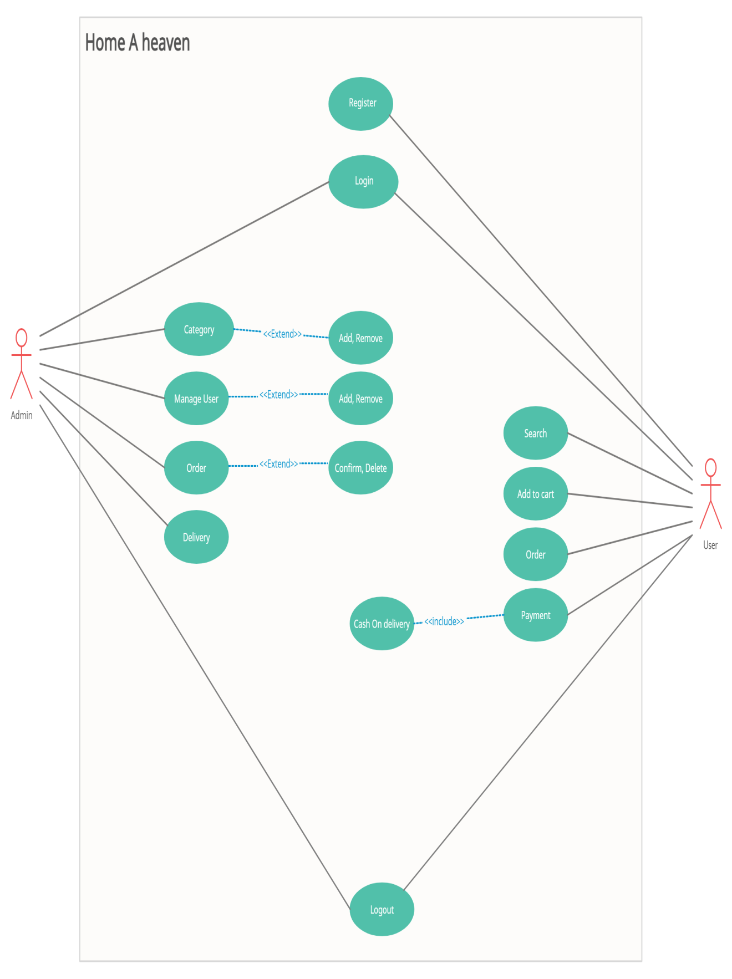

**Usage Scenarios:**

|  |  |
| --- | --- |
| Case Title | Register |
| Id | 1 |
| Actor | User |
| Actions | Users have to click on the Registration button. |
| description | User can register himself/herself by just filling the following files   * Username * Passwords * Email Id * Contact No * Address |
| Alternative paths | User can also visit this site without registration |
| Pre-conditions | The site will be open for all users. |
| Post-conditions | Then the user could be login to perform their task and logout. |
| Author | BC150403336 |
| Exceptions | It occurs if some provide invalid data such as wrong email id etc. |

|  |  |
| --- | --- |
| Case Title | Login |
| Id | 2 |
| Actor | Admin |
| Actions | Admin should have to fill login form |
| description | Admin should have to give userId and password for login to perform all tasks i.e manage category, users, and orders. |
| Alternative paths | Login is required for admin to perform all admin tasks |
| Pre-conditions | Admin hasn’t right before login |
| Post-conditions | After Login admin can perform his all task  i.e manage user, product, order, and delivery items. |
| Author | BC150403336 |
| Exceptions | It occurs if Any fields (UserId or password would be invalid) |

|  |  |
| --- | --- |
| Case Title | Login |
| Id | 3 |
| Actor | User |
| Actions | User should have to fill login form |
| description | User should have to give userId and password for login |
| Alternative paths | User can also perform his all tasks without login |
| Pre-conditions | Users will have all rights without login. |
| Post-conditions | User will have all rights and get his/her account for any other updated items selection. |
| Author | BC150403336 |
| Exceptions | It occurs if Any fields (UserId or password would be invalid) |

|  |  |
| --- | --- |
| Case Title | Category |
| Id | 4 |
| Actor | Admin |
| Actions | Admin should have to login first. Then admin can update the list.   1. Click on the category section of the application. 2. Perform the desired operation in this section. |
| description | Admin can manage all categories. Admin can add/delete or update any category. |
| Alternative paths | Login is required to do all tasks. |
| Pre-conditions | Login is required. |
| Post-conditions | According to the specified operation, the category will be updated into the database. |
| Author | BC150403336 |
| Exceptions | Login is required to perform all task. |

|  |  |
| --- | --- |
| Case Title | Manage User |
| Id | 5 |
| Actor | Admin |
| Actions | Admin should have to login first. Then the admin can manage the user list.   1. Click on the database section of the application. 2. Perform the desired operation in this section. |
| description | Admin can manage all customers from the application. Admin can search, update, and delete any customer from the application. |
| Alternative paths | Admin Login is required |
| Pre-conditions | Admin login is required |
| Post-conditions | Admin gets notified after performing a particular action on managing customers. |
| Author | BC150403336 |
| Exceptions | None |

|  |  |
| --- | --- |
| Case Title | Order |
| Id | 6 |
| Actor | Admin |
| Actions | Admin should have to login first. Then admin can manage order list.   1. Go to the order section and manage orders. 2. Perform the desired operation in this section. |
| description | Admin can manage and search all orders from the application. Admin can approve or delete any order from the application. |
| Alternative paths | Admin Login is required |
| Pre-conditions | Admin must be login before managing orders. |
| Post-conditions | Admin gets notify on a particular action. |
| Author | BC150403336 |
| Exceptions | None |

|  |  |
| --- | --- |
| Case Title | Delivery |
| Id | 7 |
| Actor | Admin |
| Actions | Admin should have to login first. Then the admin can manage the user list.   1. Go to the order section and manage orders. 2. View the order delivery report. 3. Perform the desired operation in this section. |
| description | Admin can manage and view all orders delivery report from the application. |
| Alternative paths | Admin Login is required |
| Pre-conditions | Admin must be login before managing orders. |
| Post-conditions | Admin gets notify on a Completer task. |
| Author | BC150403336 |
| Exceptions | None |

|  |  |
| --- | --- |
| Case Title | Search |
| Id | 8 |
| Actor | User |
| Actions | 1. Open website. 2. Search the desired item by using the search bar or from the category 3. Get items according to search. |
| description | Users can search for different books through categories and sub-categories and can also search through the proper search bar and get their desired item. |
| Alternative paths | User can view category when he/she couldn’t found search items |
| Pre-conditions | Run the application and type in the front search bar or explore different categories from the front. |
| Post-conditions | Users can view the details of their desired items and view details. |
| Author | BC150403336 |
| Exceptions | None |

|  |  |
| --- | --- |
| Case Title | Add to cart |
| Id | 9 |
| Actor | User |
| Actions | 1. Open website. 2. Select a product then add it to the cart |
| description | The products in which the user is interested are selected and they store in a field which is a cart. Here users can do more selection to order the product. |
| Alternative paths | None |
| Pre-conditions | Users can view items according to his/her desires. |
| Post-conditions | After adding to the cart item will be saved on the user account. Where he/she can add more or remove selected items |
| Author | BC150403336 |
| Exceptions | None |

|  |  |
| --- | --- |
| Case Title | Order |
| Id | 10 |
| Actor | User |
| Actions | 1. Open website. 2. Go to add to cart section 3. User can order all items in add to cart section. |
| description | User can order all items which he/she save in add to cart section. Where the user can add more items or delete any item. Users can view his/her total items number and the total price of selected items. |
| Alternative paths | None |
| Pre-conditions | Order items will be saved in addition to the cart section. |
| Post-conditions | Order will be on the way after confirmation order. |
| Author | BC150403336 |
| Exceptions | None |

|  |  |
| --- | --- |
| Case Title | Payment |
| Id | 11 |
| Actor | User |
| Actions | 1. Open website. 2. Go to add to cart section 3. Choose item. 4. Add to cart. 5. Fill the form of Cash on delivery. |
| description | Customers can pay on delivery. |
| Alternative paths | None |
| Pre-conditions | Some items to checkout items will be saved on his/her cart section. |
| Post-conditions | The customer will proceed to checkout. |
| Author | BC150403336 |
| Exceptions | None |

|  |  |
| --- | --- |
| Case Title | Logout |
| Id | 12 |
| Actor | User |
| Actions | 1. Press Logout Button. |
| description | Users can logout from the application. |
| Alternative paths | None. |
| Pre-conditions | Members must be login into the system. |
| Post-conditions | Sessions will be destroyed and the user redirected to the login page. |
| Author | BC150403336 |
| Exceptions | None |

|  |  |
| --- | --- |
| Case Title | Logout |
| Id | 13 |
| Actor | Admin |
| Actions | 1. Press Logout Button. |
| description | Admin can logout from the application. |
| Alternative paths | None. |
| Pre-conditions | Admin must be login in to the system at that time admin will have all rights to update any tasks. |
| Post-conditions | Sessions will be destroyed and admin redirected to the login page and now admin has any admin rights. |
| Author | BC150403336 |
| Exceptions | None |

Adopted Methodology

As Vu process model is the combination of the waterfall spiral method. So, I decided to you this method where we can use both of these models. Each model has its beauty so this model will make my project more beneficial, more interactive. I can develop my project easily using this process model.

Let me explain both of these models.

**Waterfall Model**It is a linear sequential model where we move forward from one stage to another sequentially and can track our progress about the project. The waterfall system is the most traditional method for managing a project. In this model where each stage depends on the deliverable of the previous stage and corresponds to a specialization of tasks.

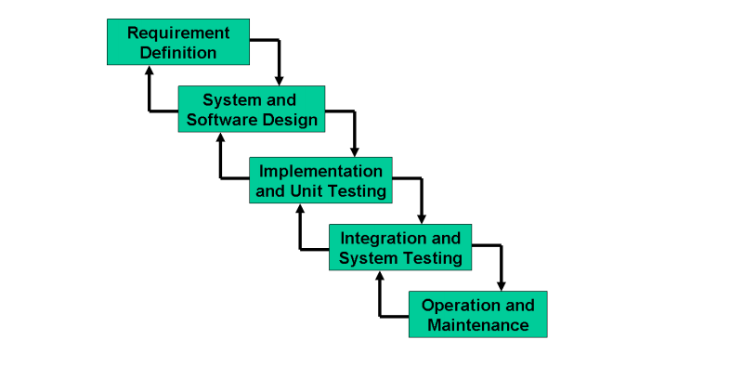

**Spiral Model**

The spiral model is a risk-driven software development process model. This model base on unique risk patterns. It guides to adopt elements of one or more process models such as incremental, waterfall, etc. This model is good for large and mission-critical projects, strong documentation control, and more functions can be added at a time or later date.

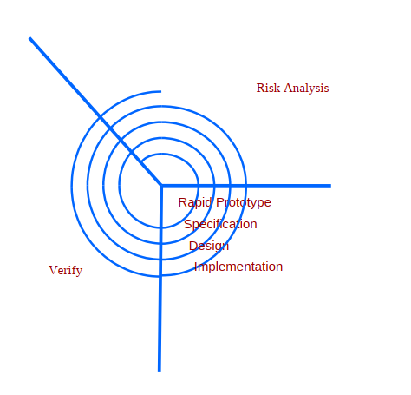

Work Plan (Use MS Project to create Schedule/Work Plan)

